

SMA
USER GUIDE
Version 2.2
SMA – SERVICE MANAGEMENT ADMINISTRATION

1 Getting on the System - 1
2 Change Control Procedures – User Group - 2
2.1 Role of the User Group - 2
2.2 Change Process - 2
3 Standard Features for SMA - 3
4 Customer Management – Customer Service Manager/Specialist - 7
4.1 Search a Customer Name - 6
4.2 Adding a Customer Name - 9
5 Customer Address - 10
5.1 Search a Customer Address - 10
5.2 Create Customer Address - 11
5.3 Change a Customer Address - 12
6 Service Location - 13
6.1 Search/Create a Service Location - 13
7 Contact Information - 15
7.l Search/Create a Contact - 15
7.2 Adding/Changing/Deleting Customer Contact Information - 16
8 Contact Roles - 18
8.1 Contact Role Search/Create - 18
8.2 How Remedy Uses Contact Information - 19
9 Customer Services - 21
9.1 Search a New Customer Service - 21
9.2 Adding a New Customer Service -22
9.3 Changing a Customer Service Type (Upgrade/Downgrade the service) - 27
9.4 Moving the location of a Customer Service - 27
9.5 Customer Services - Email Setup - 27
10 Facilities - 28
10.1 Facility Search - 28
10.2 Facility Detailed Circuit Information - 29
10.3 Facility Detail Specific - 32
11 Assets - 34
11.1 Asset Search - 34
11.2 Asset Catalogue Search - Make, Model and Part Search - 37
11.3 Creating/Deleting Asset Catalogue, Make, Model, Part# and Asset Class, Subclass or Type - 38
12 Managed Objects – Design Engineers - 39
12.1 Search a Managed Object - 40
12.2 Create a Managed Object - 40
12.3 Inactivating Managed Objects - 41
13 ATM PVC Management - 41
13.1 Search PVC - 42
14 Correlation Management - 45
14.1 Search Correlated Elements - 45
14.2 Attaching Correlated Elements to the Customer Service - 46
14.3 Activating/Terminating the Customer Service - 47
15 Administration - 47

Revision History

Date | Version | Contributor | Comments
1998-06-22 | 1.0 |  | Initial Document
2000/02/28 | 2.0 | Bruce Adlington | Revised to reflect system version 4.6.1  (This document is still under construction)
2000-03-27 | 2.1 | Bruce Adlington | Updated section 6 – Managed Objects
2000-10-05 | 2.2 | Ann Pyear | Revised to reflect system version SMA2, Version 1

SMA – Service Management Administration

SMA is a software tool, created by TELUS, to help make the tasks of creating and managing Network Services more efficient. It is an interface to the ESD (Enhanced Services Database).
Customer orders are:
Created in SRT and DOCS
Tracked through ECOPS
Designed on Visio
Trouble reporting is via Remedy and T2
Billed on Arbor

SMA is a critical link in TELUS’s ability to provide ‘Service Management’ because it integrates all the activities and data that we need to manage to meet out contracts with our customers.

Detailed of processes for the Enhanced Services are found at

http://tacjagr1.office.tac.net/esdreports/esots/index.html

Getting on the System:

The following information is required for each SMA User in each functional group:

- User Name
- User Location (including building and floor)
- M# of User's desktop or laptop
- User ID
- Functional Group (used to create security profile)
- Email ID, only if your ID does not follow the standard format of Jim.wilkin@telus.com
- TAC Domain

The above information is used to establish the User's security profile. Security profiles must be established to provide the User with access to SMA 2 and also establish the authority they have to execute specific SMA 2 transactions.

SMA2 web address - http://tacabweb10/sma2

Need Internet Explorer 5 – deployment underway

IE5 options to use:
Properties-General-Temporary Internet –File Settings –”refresh page every visit”
Properties – Connections – Lan Settings – uncheck “use Proxy Server”

Change Control Procedures –User Group

Role of the User Group

The User Group is made up of the Super Users identified in the SMA Process Ownership Model plus additional representatives from the IT department who represent systems that may be affected by the proposed changes.

The role of the Super User is to represent their peer group in the ownership of process, function and data for their area of responsibility. Super user responsibilities include:

- Identify and collect ideas for improvements from peer users.
- Analyze the impact of the improvement with regards to their function(s).
- Responsibly escalate improvement ideas and issues that overlap functional boundaries with the User Group for discussion.
- Participate in issue resolution to ensure the needs of the entire “Service Management” process are met.
- Update User Procedures document to reflect changes.
- Disseminate new and changed information to their peer group.

The role of the User Group Meeting is to serve as a forum where all issues regarding any process, data or system function can be shared with the other Super Users and IT representatives. The purpose is to fully understand the implications that a change or addition may have on other groups in the process. The primary responsibility of the User Group Meeting is to:

- Review and prioritize improvement ideas raised by Super Users since the previous meeting.
- Resolve issues that affect more than one functional area.
- Ensure system change requests are logged in the C3S program
- Review and approve change requests implemented in the latest release.

Change Process

Each Super User is responsible for issue resolution and maintenance of documentation within their functional areas.

Any change relating to DATA, PROCESS or SYSTEM should follow the following process:

- Conduct a preliminary analysis of the change request.
Ensure the change request is valid and that it cannot be solved with training. If the change request is valid, identify the groups that may be affected by the change. Get input from the identified Super Users regarding the potential impact of the change request.
- Log the change request as an item on the user group meeting agenda.
E-mail a note to the User Group Coordinator (currently Lee Ettinger). The note should contain a short description of the issue and an estimate of the amount of time it will take to fully discuss the issue in the meeting. Try to be realistic in your time estimate so that the meeting can be planned to cover all items.

AT THE USER GROUP MEETING

- Review and Discuss items on the agenda. The Super User responsible for logging the item should give background information on the change request for the rest of the user group.
- If it is determined by the user group that the change request is required and valuable continue with step 5, otherwise the issue should be closed and the Super User responsible for logging the item should communicate the resolution to the original requestor.
- If the change request results in enhancements or changes to the system, log the change request in the C3S application.
- If the change request results in process or data changes, each Super User is responsible to update the new process in the Procedures Document and also to communicate the new procedures to their peer user group.

Standard Features in SMA

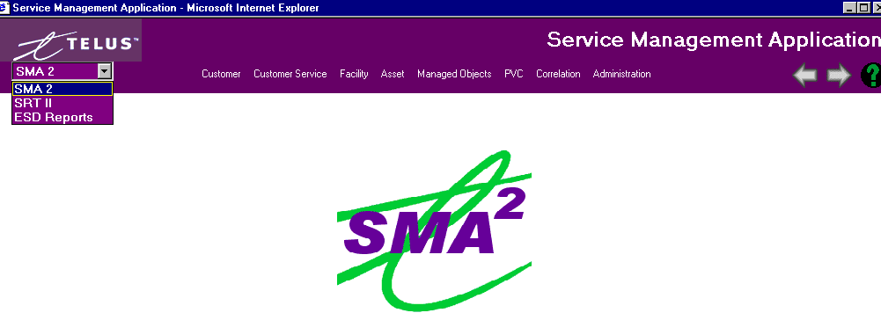
Pulldown menu for INOSS applications
User Action buttons

Forward/Backward (navigate screens)

? - SMA User Guide
SMA2
Main menu
choices

“alias name” field identifiers – If there has been company takeovers, etc. these alias names will assist in searching process. Used for Customer Name, Facility Number, and Managed Object Name.

Enhanced search capabilities with
- wild card support using ‘%’ character, i.e. f%r, SMA assumes a wild card at the end of your search
- Text searches are ‘not case sensitive’

“Quickly GoTo” linkage from detail screen allows easy navigation

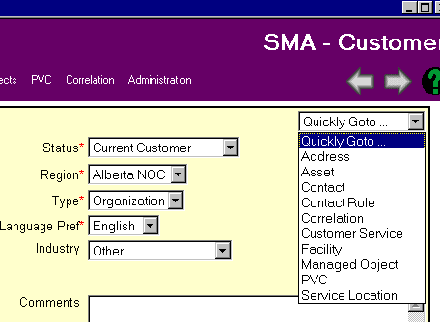
Mandatory fields
Marked with ‘*’

Drop down menus, usually there is also a blank choice available

User button bar strips for easy access to editing details:

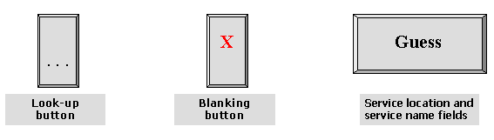

Standard User Button Bars:
Highlight line in box that you want to delete
Refreshes screen to original form.

Add a new item
Highlight a line to change.
AUDIT INFORMATION
The last change to record will be shown
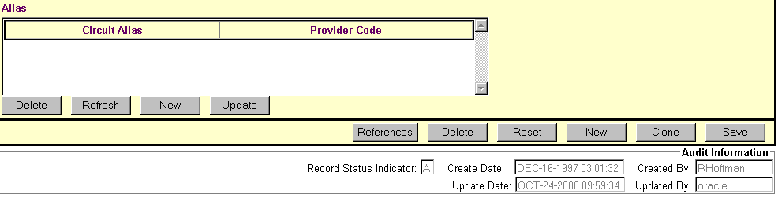
Details associated records. Important when deleting records
Clears any changes to data fields you’ve made
Saves record
‘hard’ delete of record (security rights req’d) This removes the record from SMA. Use ‘Terminated’ status for discontinued circuits
Clones record that is on screen (not on all screens)
Creates new record

Search Screen User Buttons:
Active Only are records that have been deleted from the previous version of SMA, plus the DOCS and SRT systems. There are no deleted records from the existing SMA2.
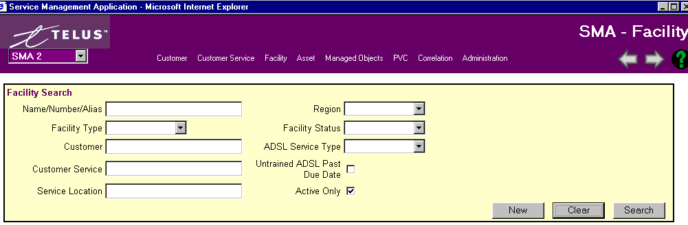
Create a new record
Clear search criteria
Click to start Search or hit Enter

ALWAYS SAVE YOUR WORK. You will receive a warning if you try to exit out of screens that you have changed asking if you are sure you want to leave without saving your work.

STATISTICAL DATA FROM SEARCHS:

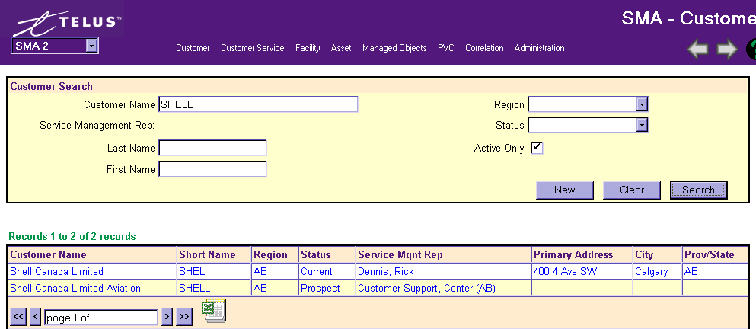

After running any search you can capture the data by clicking on the ‘Excel Icon’.

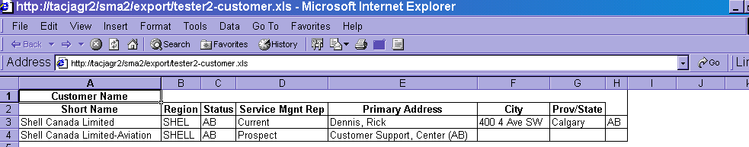

This Excel spreadsheet can be filed ‘Save As’ in your own drive and manipulate the data however you want. This is an excellent new tool for Individual Reports.

Customer Management

Note: Customer, address, and contact information are captured in SRT/DOCS. Therefore, it should not be necessary to add data using SMA. SMA is used to maintain the data.

Search a Customer Name
***Please read Section 2.0 ‘Standard Features of SMA’***

Go to the SMA Main Window – Customer then click Search
The following window will display:
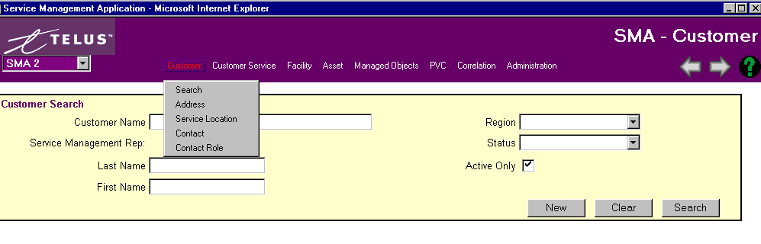
Search for the customer using any of the fields shown above.

Remember the more fields you define the narrower your search results, i.e. inputting into the Customer Name and also the Region will give look up the customer is the selected Region only.

If you are not sure of the full name, use the ‘%’ wild card within any of your inputs. Wild cards are not necessary at the end of your search.

A Legal name, short name, or alias name can be used in the Customer Name field when searching.

A list of customers will appear from the Search query. If it is taking a long time or you hit Search without putting any criteria down just hit the ‘ESC’ button on your PC to stop the task.

Results from search:
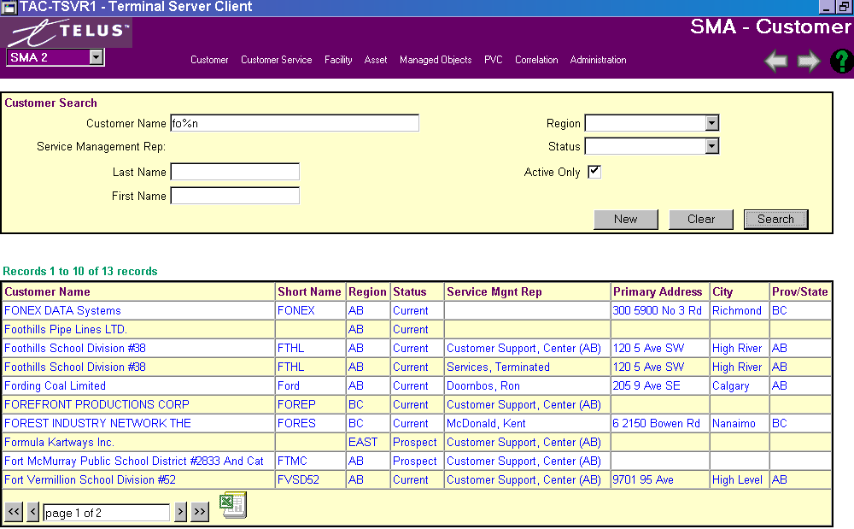

Shows amount of records found. Use arrow bars at bottom of screen to either go page by page (single arrows) or to the first or last page (double arrows). You can also jump to a page by typing the # into the box.

Double click on your selection to go to Customer Detail.
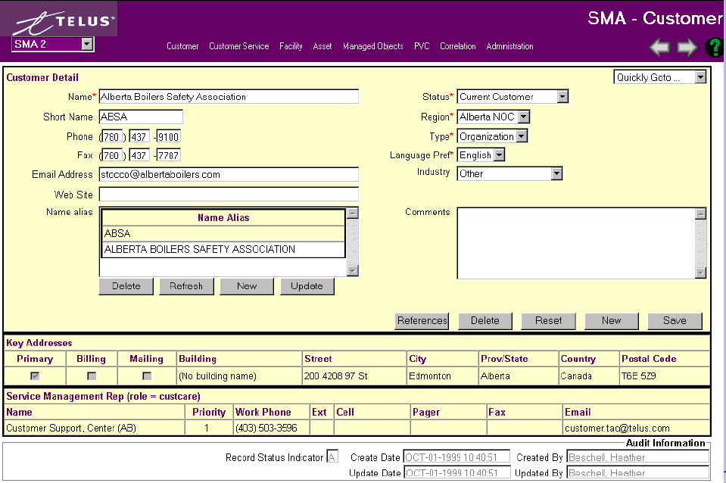
Field descriptions are on the next page. Key Address and Service Managements Rep information extractions from Address and Customer Contact screens.

ADDING A CUSTOMER NAME

If the customer does not exist then you must add it to the database. (This should only be necessary if there is not a DOCS order issued)

Click ‘New” on Customer Search screen to bring up Customer Detail page.

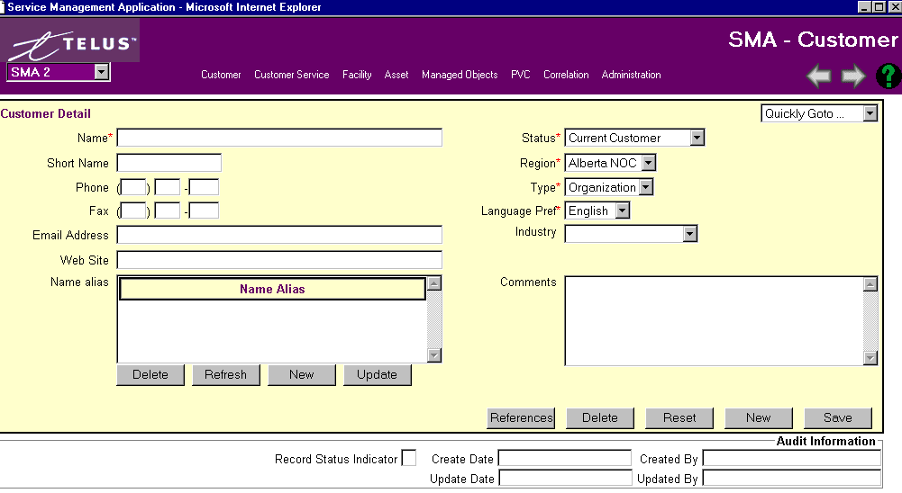

Name - should contain the legal name of the company. Take great care to ensure the company name is entered as correctly. (no extra spaces, periods, correct spelling etc.) as possible.
The client name is used on reports and correspondence to the client and therefore it is very important that it is as accurate as possible.

Short Name - is used as a short reference to the legal Client Name. For example, Client Name: TELUS Advanced Communications, Client Short Name: TAC. Once the short name is defined, it is used as a component of the service name, and is used to access HealthNet and CURE reports. The short name can be a maximum of 5 characters.

Phone#, Fax#, E-Mail Address, Web Site - fields are contact information for this customer.

Name Alias - will always show the Customer Name and Short Name. If there are additional names, i.e. business takeovers, nicknames, etc. adding these will help in the searching capabilities.

Status - choose from drop-down menu, i.e. Current Customer, Perspective Customer.

Region - choose from drop-down menu, i.e. Alberta NOC, BC NOC, Eastern NOC

Type - choose from drop-down menu, i.e. Organization, Person

Language Pref - choose from drop-down menu, i.e. English, Chinese
Industry - choose from drop-down menu, i.e. Education, Finance, etc.

Comments - any additional information pertinent to this customer.

ALWAYS SAVE YOUR WORK. You will receive a warning if you try to exit out of screens that you have changed asking if you are sure you want to leave without saving your work.

You can now use the “Quickly GoTo’ to access Address, Asset, Contact, Contact Role, Correlation, Customer Service, Facility, Managed Object, PVC or Service Location

CUSTOMER ADDRESS
***Please read Section 2.0 ‘Standard Features of SMA’***

Search a Customer Address
Go to the SMA Main Window – Customer then click Address

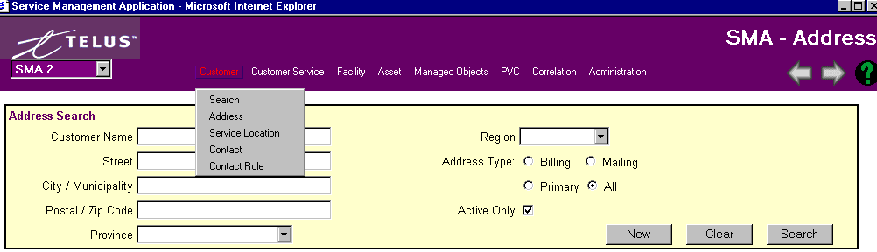

Since a large amount of addresses in SMA start with a Floor or Suite number, use a wild card ‘%’ at the beginning of your search. Remember the more fields you define the narrower your search results, i.e. input a City, Type of Address (Billing, Mailing, Primary). Customer Name can also be the Alias name.

Search Result:
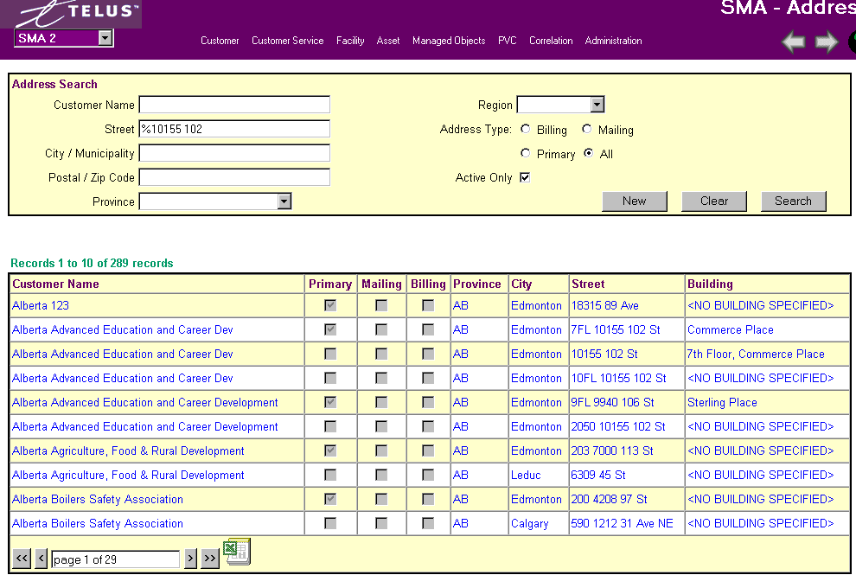Shows amount of records found. Use arrow bars at bottom of screen to either go page by page (single arrows) or to the first or last page (double arrows). You can also jump to a page by typing the # into the box.
If none of the Address Types are checked assume the address is a service location.

Create Customer Address
To Create an address, Hit ‘New’ on Search screen or Address Detail screen. (This should only be necessary if there is not a DOCS order issued)

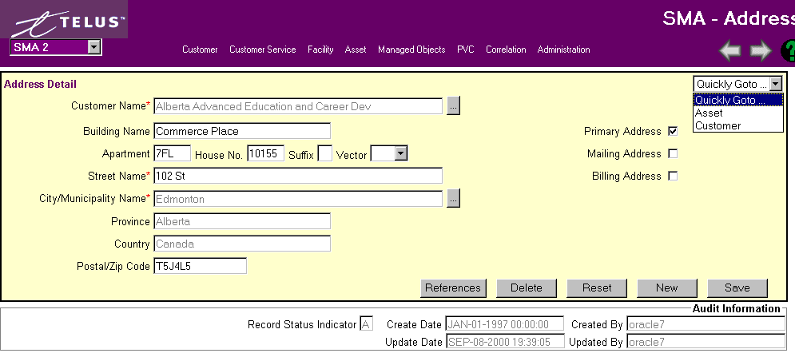

There must be an address for every service location.

Customer Name – Must use the Look-up button, which takes you to the Customer Name Search screen.

Building Name – The Building Name is not mandatory, but if it is known, it should be the official name of the building.

Apartment – Floors and Suite #s are inputted in this field.

House No. - Specific number of house or building.

Suffix – If address includes a suffix, i.e. A, 1/2

Vector – For a direction (E, N, etc) that proceeds the Street or Avenue, i.e. 3700 N. Fraser Way.

Street Name – Numeric or alpha name for Street or Avenue

City/Municipality – Must use Look-up button, which takes you to the Municipality Search screen.

Province/Country/Postal/Zip Code – self explanatory.

Types of Address:
Use the check boxes to define the address (more that one box can be checked). It is mandatory to define a Primary Business address.
Primary Address – main address for customer
Mailing Address – where any information concerning the service is mailed to
Billing Address – where the bill is sent

From this screen you can Quickly Goto… either the Asset or Customer screen.

Change a Customer Address

An address should be changed only if the information has been entered incorrectly.

If the customer is moving addresses, then a new address should be created.

Service Location
***Please read Section 2.0 ‘Standard Features of SMA’***

Search/Create a Service Location
Go to the SMA Main Window – Customer then click Service Location

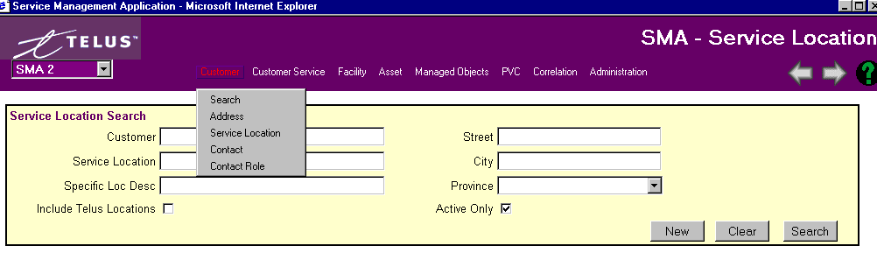

A Legal name, short name, or alias name can be used in the Customer Name field when searching.
Remember the more fields you define the narrower your search results.

A list of Service Locations will appear from the Search query. If it is taking a long time or you hit Search without putting any criteria down just hit the ‘ESC’ button on your PC to stop the task.

SEARCH RESULTS:
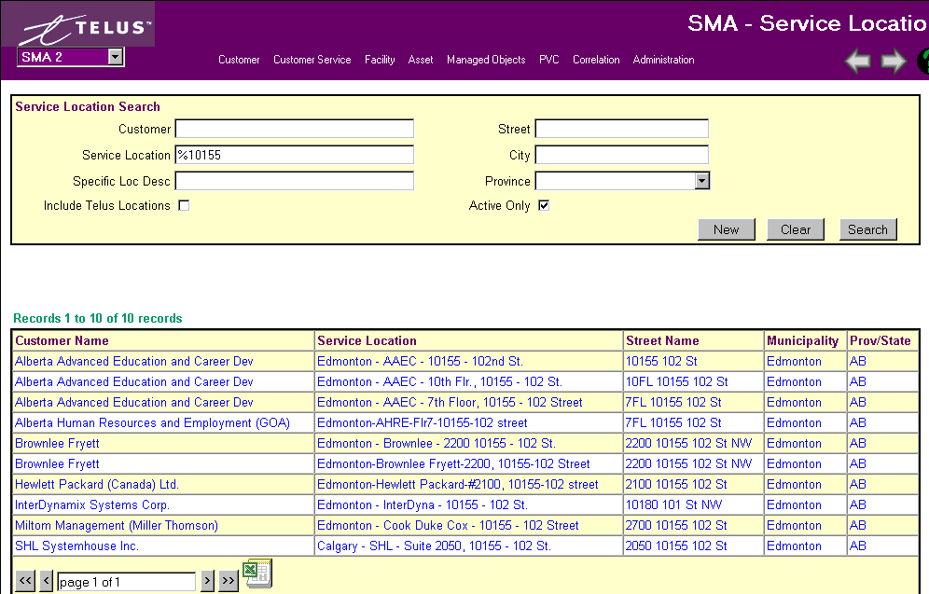
Shows amount of records found. Use arrow bars at bottom of screen to either go page by page (single arrows) or to the first or last page (double arrows). You can also jump to a page by typing the # into the box.

To Create a Service Location, Hit ‘New’ on Search screen or Service Location Detail screen. (This should only be necessary if there is not a DOCS order issued)

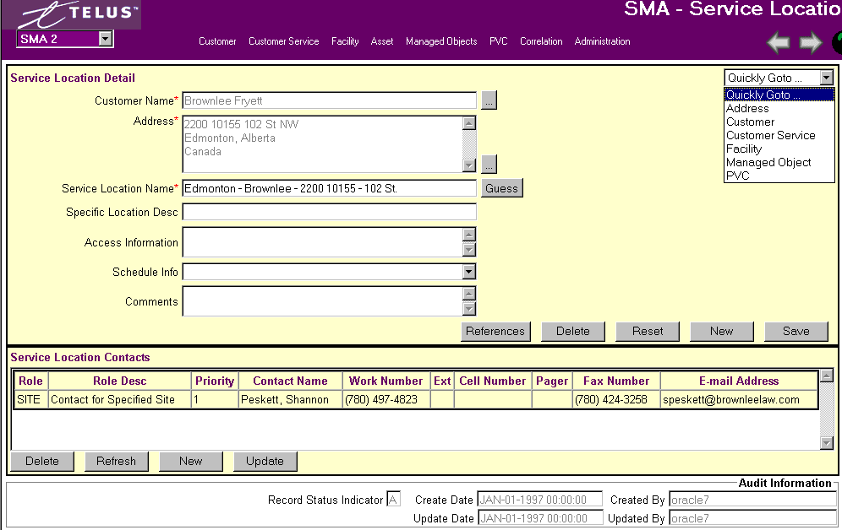

Fields:

Customer Name – Must use the Look-up button, which takes you to the Customer Name Search screen.

Address – Must use the Look-up button, which takes you to the Address Search screen.

Service Location Name – Format is (City Name – Customer Name – Address)

Specific Location Desc. – Any additional details concerning this specific location.

Access Information – Any specific details concerning the access to the building.

Schedule Info – Drop-down menu to select times when location available.

Comments – Any additional information concerning this service location.

Service Location Contacts – Options to create ‘New’, ‘Update’, or ‘Delete’. See next page for details.

From this screen you can Quickly Goto… either the Address, Customer, Customer Service, Facility, Managed Object or PVC screen.

To create, update or Delete the Service Location Contact Detail:

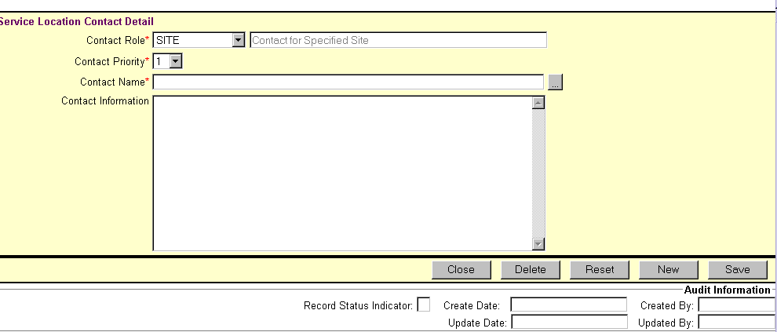

Fields:

Contact Role – Drop-down menu to select what type of role this contact has for this Service Location. A full description will appear in the adjacent field.

Contact Priority – A rating of 1 – 10 of what priority this contact has been given.

Contact Name – Must use Look-up button to select from Contact Screen.

Contact Information – Extracted from information on Contact Screen.

Contact Information
***Please read Section 2.0 ‘Standard Features of SMA’***

Search/Create a Contact

Go to the SMA Main Window – Customer then click Contact

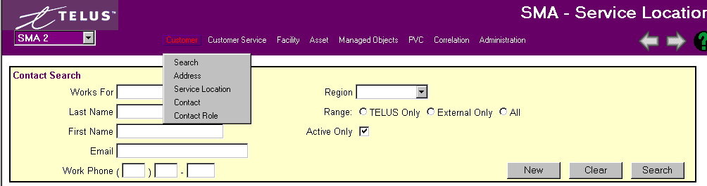

Search for the contact information using any of the fields shown above.

Remember the more fields you define the narrower your search results, i.e. inputting into the First Name field and also the Region will give you all the first names is the selected Region only.

If you are not sure of the full name, use the ‘%’ wild card within any of your inputs. Wild cards are not necessary at the end of your search.

A list of contacts will appear from the Search query. If it is taking a long time or you hit Search without putting any criteria down just hit the ‘ESC’ button on your PC to stop the task.

Search Result
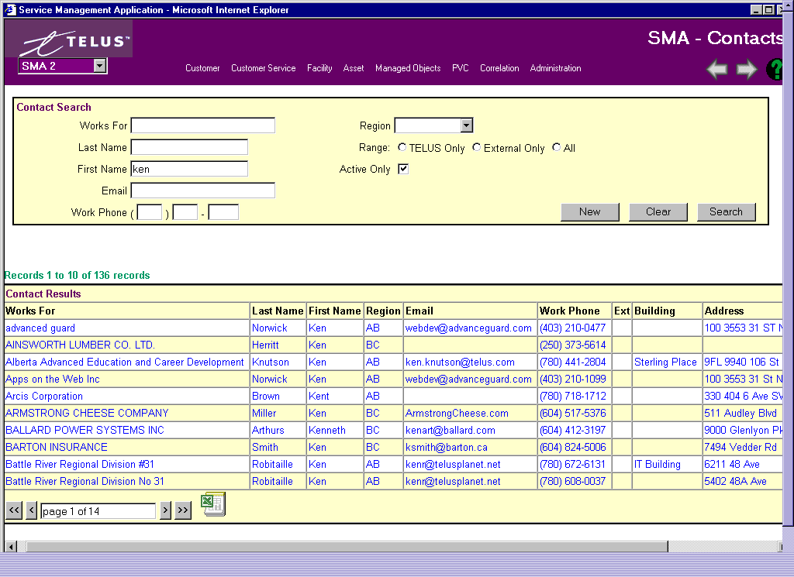
Shows amount of records found. Use arrow bars at bottom of screen to either go page by page (single arrows) or to the first or last page (double arrows). You can also jump to a page by typing the # into the box.

Adding/Changing/Deleting Customer Contact Information

Customer Service has the overall responsibility for inserting/updating/deleting customer contact information. Implementation Managers will also make changes to this tab in order to keep customer contact information accurate and current.

Any other group that receives changes to this information via the customer will notify Customer Service by e-mail. The Customer Service Manager responsible for the customer can be found in Customer Management: TAC Specific and Industry Information: Customer Care Specialist. If the Customer Care Specialist information is missing, send the information to the Super User of Customer Management.

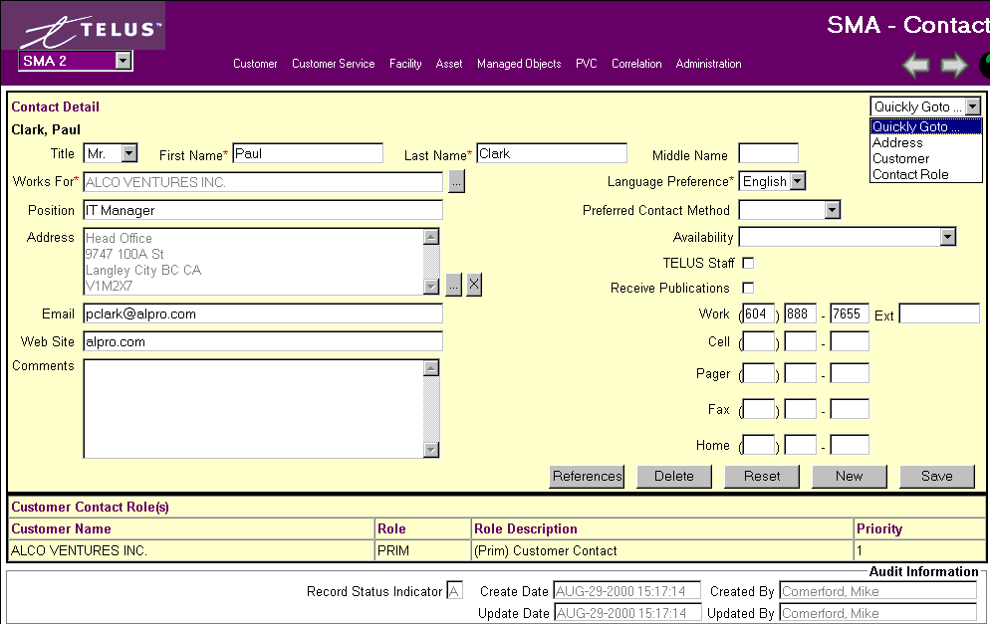

FIELDS:

Title – Select from drop-down menu

First Name/Last Name/Middle Name – Customer contact name

Works For – Use Look-Up button for Customer Search

Position – Job Title of Customer contact

Address – Use Look-Up button for Address Search. Can also use ‘X’ to remove current information.
This address is used to send communications to the Contact

E-Mail – A valid Internet E-Mail address for Contact.

Web Site – A 50-character maximum field that must start with “http://”

Comments – Includes notes that pertain to the Customer Relationship.

Language Preference – Drop-down selection on the language the contact prefers, i.e. English

Preferred Contact Method – Drop-down selection for how the contact wants to be contacted, i.e. Cell, E-mail, work #, home #, etc.

Availability – Drop-down selection of the times when the Contact is available.

Telus Staff - Identifies this contact as a Telus employee.

Receive Publications - indicates whether or not the customer wants to receive a newsletter.

Work#, Cell#, Pager, Fax# and Home # - the personal information for the Customer contact.

Customer Contact Role(s) – Details extracted from the Customer Contact Role Screen.

Service Location Contact Role(s) – Details extracted from the Service Location Detail Screen.

From this screen you can Quickly Goto… either the Address, Customer, or the Contact Role screen.

Contact Roles

Contact Role Search/Create
***Please read Section 2.0 ‘Standard Features of SMA’***

Go to the SMA Main Window – Customer then click Contact Role

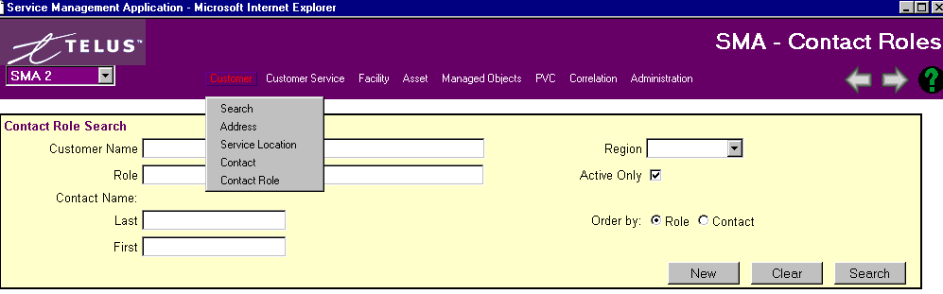

Search for the contact role information using any of the fields shown above.

Remember the more fields you define the narrower your search results, i.e. inputting into the First Name field and also the Region will give you all the first names is the selected Region only.

If you are not sure of the full name, use the ‘%’ wild card within any of your inputs. Wild cards are not necessary at the end of your search.

A list of customers will appear from the Search query. If it is taking a long time or you hit Search without putting any criteria down just hit the ‘ESC’ button on your PC to stop the task.

Search Results
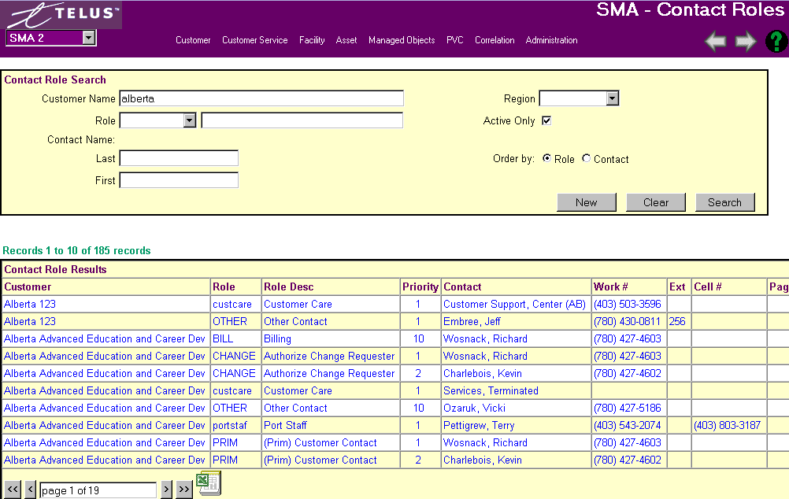

Use the pull-down to select and view the roll definitions. Every customer must have a PRIM 1 contact – This is the primary technical contact for the customer and is the fallback contact used by the Remedy system for Trouble Ticketing. . It is recommended that PRIM 1 and PRIM 2 always be assigned. Refer to the next paragraph for more information on roles and priority.

How Remedy Uses Contact Information
Phone Contact
There are often many contacts for each customer, and each contact can have one or multiple roles assigned to them. The important thing to remember is that these contacts, in the database are used by Remedy T2 and C2, and by Operations to provide contact information when alarms are detected on TAC equipment located at their sites. These automatic alarms create Remedy T2 tickets, which will have customer contact information attached.

By default, Remedy will attach the SITE1 contact to any automatic (Spectrum created) trouble ticket on any specific element. This will only happen if a customer contact is defined as a SITE contact and the specific element is linked to that site location and customer in the SMA Managed Objects. Otherwise, if no site contact is available, the PRIM1 will be attached. If neither a SITE1 nor PRIM1 is defined for the customer, the contact information in the ticket will be blank. However, all contacts can be queried via the pull down menu on the ticket. The SERV1 contact is only used for E-Mail notification.

It is valuable to have site contacts when the OSC requires confirmation of power and physical connectivity, as in most cases, the tickets are created by the systems and not called in by the customer. In cases where we have customers that want a single point of contact from a networking perspective, then SITE contacts should not be defined, and the PRIME1 should be the customer helpdesk or main technical contact (7x24).

E-Mail Contact
Contact information is also used by Operations when sending email notification to customers for upcoming maintenance window activity that will affect their service, and for customer notifications and updates when a global outage occurs that affects multiple customers and services.

From both C2 and T2, an email distribution can be created for the customers that are linked to the service tags on any change ticket or trouble ticket. As a result of service correlation, any element that has a change or trouble ticket can have an email distribution list created for quick and easy notification. Obviously, this is only possible if the customer contacts are defined properly in the ESD and their correct email addresses are also entered.

Email notification (for all customer services) will be sent to the following customer roles:
- PRIM1 (Helpdesk- email should be the helpdesk email or an email that distributes to multiple contacts within the organization).
- PRIM2 (Manager or Lead Communication Analyst)
- SERV1 (Technical contact for a specific service i.e. Web Hosting).

The only time a SERV1 contact needs to be defined is if a specific customer has multiple services, and for some of these services they would like a different person contacted. We find this to be the case when a customer has purchased both Internetworking and Internet Hosting services. Often the customer’s organization is such that different people are responsible for the LAN/WAN and the Hosting Services.

Change Control
Another Role is the CHANGE role. This is used by operations to confirm that a specific customer contact has the authority to request changes to an existing service. The customer change process allows a customer to request a change by emailing the OSC with the details. This email must be received from an authorized change requestor for that customer. So, if a customer is going to be requesting changes, the contacts that are authorized must have CHANGE roles assigned in the ESD.

Summary
Customer contact information is defined and maintained by Customer Service Management. It is very important that they ensure that customer contacts are correct and have the proper roles assigned to them. Service Management should verify that the contact information is correct when they do their quarterly customer service reviews.

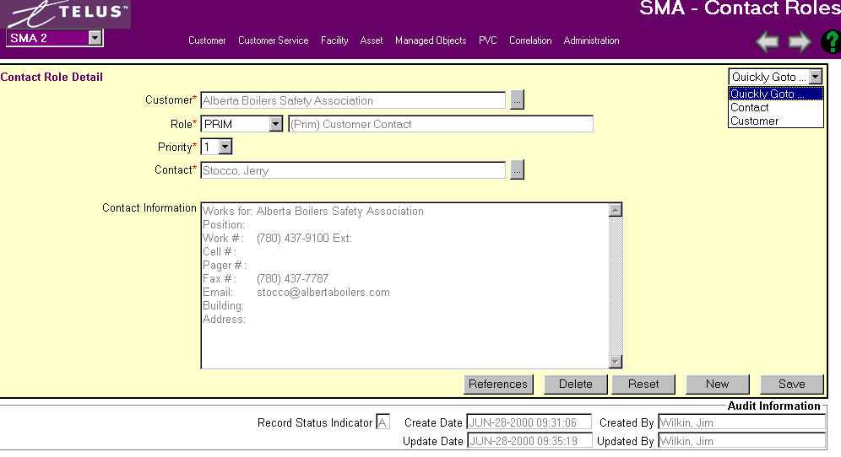

Customer – Must use the Look-up button, which takes you to the Customer Name Search screen.

Role – Drop-down selection for Type of Role the contact is. Once the selection is made the full Role name will be displayed in the adjacent field.

Priority – Choose from 1 – 10 as what priority this contact role is.

Contact – Must use the Look-up button, which takes you to the Contact Search screen.

Contact Information – Information is extracted from Contact Search screen.

From this screen you can Quickly Goto… either the Contact or Customer screen.

CUSTOMER SERVICES
***Please read Section 2.0 ‘Standard Features of SMA’***

Search Customer Services
Go to the SMA Main Window – Customer Services then click Search.
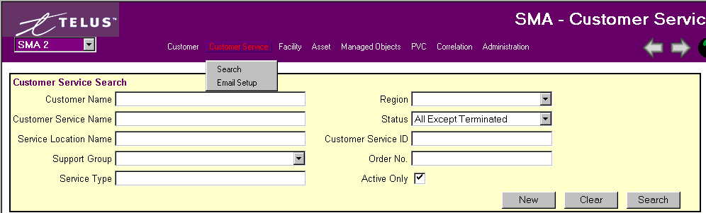
Search for the customer service name using any of the fields shown above.

A Legal name, short name, or alias name can be used in the Customer Name field when searching.

Remember the more fields you define the narrower your search results.

If you are not sure of the full name, use the ‘%’ wild card within any of your inputs. Wild cards are not necessary at the end of your search.

A list of customer service names will appear from the Search query. If it is taking a long time or you hit Search without putting any criteria down just hit the ‘ESC’ button on your PC to stop the task.

SEARCH RESULTS:
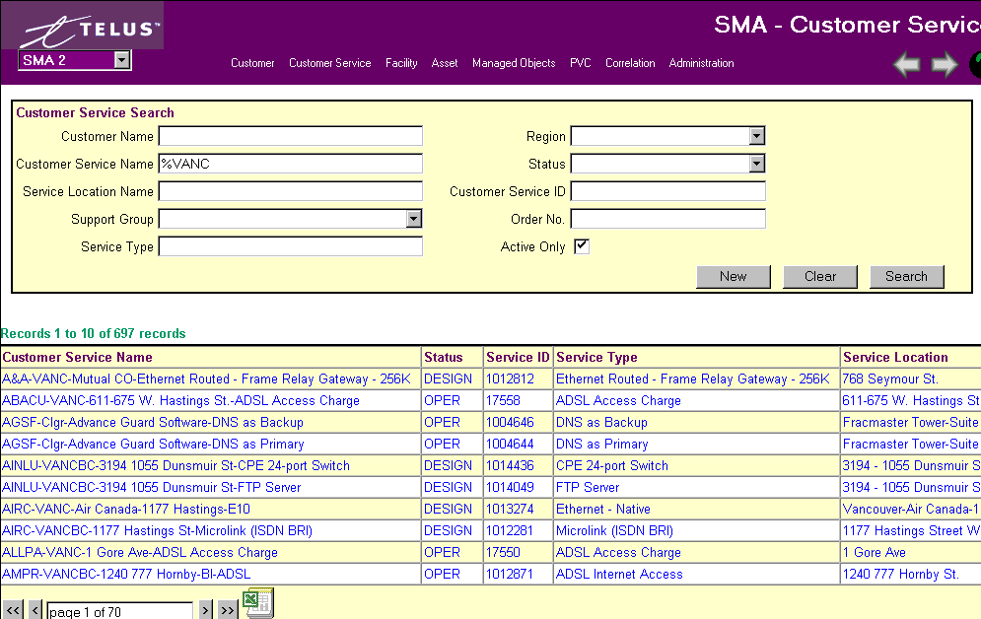
Screen also shows Customer Name, Region, and Support Group.

Shows amount of records found. Use arrow bars at bottom of screen to either go page by page (single arrows) or to the first or last page (double arrows). You can also jump to a page by typing the # into the box.

ADDING A NEW CUSTOMER SERVICE
The Customer Service Name is a unique reference to this customer service. The standard naming convention is as follows:
Customer Short Name ‘-‘ Abbreviated City Name ‘Abbreviated Province Name’-‘ Unique Identifier (i.e. building name, street address, floor number, etc.) ‘-‘Service Type’.
Example: ACB-EDTN-Cross Cancer Institute-Ethernet Native.
If the service is Ethernet Native, Fast Ethernet Native, LAN IC, or LAN Extension, then a second service has to be built for the Standard Reporting. The Service Name will be the same as the name given to the service, with ‘SR’ added in front of the service type.
Example: ACB-EDTNAB-Cross Cancer Institute-SR-Ethernet Native.
The DOCS system can build a customer service in SMA for you. Find the order in DOCS, and select the Contacts and Provisioning tab. Select the correct service, and hit the SMA button. Note: Only those individuals who are responsible for creating services in SMA are given security access to use this DOCS feature. Also, the service must be in ECOPS, and assigned an Overall Prime before SMA can be updated.
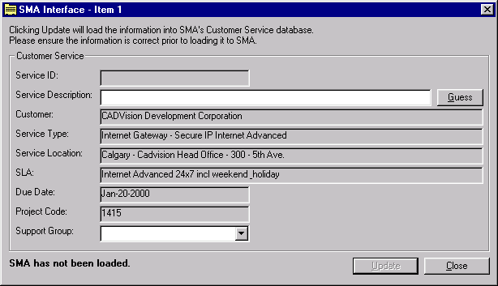
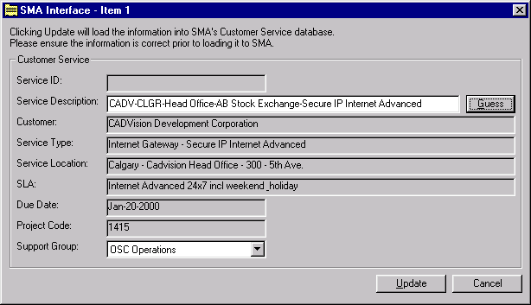
The screen shot above is the SMA screen in DOCS. Press the Guess button to have DOCS build the Service Name, and correct it manually if required. Select the Support Group, and press the Update button to load the service into SMA. Note: Project Code is the DOCS order number.

To Create a Customer Service Name, Hit ‘New’ on Search screen or Customer Service Detail screen . (This should only be necessary if there is not a DOCS order issued)

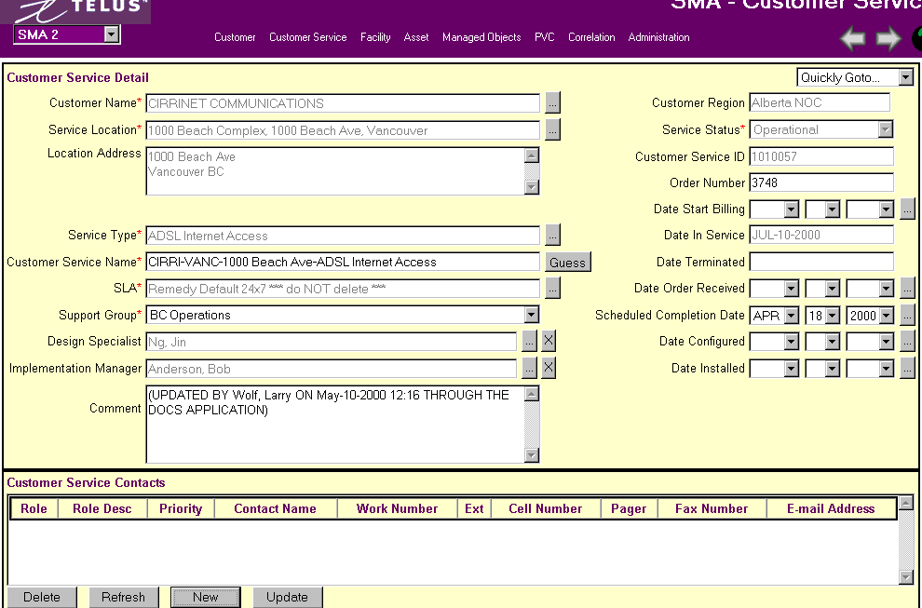
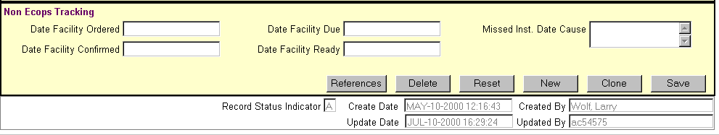

The above screen is the result of creating the Service from DOCS. Note that the Comments were automatically filled out to indicate that the service was created through DOCS.
Fields:

Customer Name – Must use Look-up table on Customer Search screen.

Service Location – Must use Look-up table on Service Location screen.

Location Address – Information extracted from Service Location screen once Service Location selected.

Service Type – Must use Look-up table from Service Type (Admin) screen.

Customer Service Name – Guess button will assist you to follow format

SLA – Must use Look-up table on Service Level Agreement (Admin) screen.

Support Group – Drop-down menu to select which Enhanced group looks after the service.

Design Specialist – Must use Look-up table on Contact screen. There is also a ‘X’ button to blank out field.

Implementation Manager – Must use Look-up table on Contact Search screen. There is also a ‘X’ button to blank out field.

Customer Region – Extracted from Customer Search screen, The Customer NOC Region as defined in Customer Management.

Service Status - Codes for a customer service:
DESIGN – When adding a new customer service, the status will default to design. A design status indicates that the customer service is not being monitored or supported by the Operations Service Centre (OSC) nor is the customer being invoiced for the service.
OPERATIONAL – The Operations Service Centre (OSC) is responsible for changing the status of a customer service to operational. An operational status indicates that the customer is free to use the service, OSC is fully monitoring and supporting the customer service and Customer Care is invoicing the customer for the service.
TERMINATED – The Operations Service Centre (OSC) is responsible for changing the status of a customer service to Terminated. A terminated status indicates that the customer can no longer access and use the service, OSC is no longer monitoring and supporting the customer service and Customer Care is no longer billing the customer for that service.

Customer Service ID – This is a unique system generated number.

Order Number - DOCS order number

Date to Start Billing – This is the same as the Date In-Service.

Date In-Service – This is automatically populated when the service is made Operational by OSC.

Date Terminated – This is automatically populated when the service is changed from Operational to Terminated by OSC.
.
Date Order Received – Manually populated, based on DOCS

Scheduled Completion Date - the date the customer service is expected to be operational.

Date Configured – If equipment needs to be configured, date is added.

Date Installed – Manually populated when the installer phones in to confirm the installation in complete.

Comments – If the service was created in DOCS, then a comment is added automatically. Otherwise, it is manual input. SAP numbers can be placed here.

The following information is used for Facility Order Tracking and Monitoring. Facility tracking is done in ECOPS, so it is not necessary to enter the following dates.
Date Facility Ordered – Enter the date the facility was ordered.
Date Facility Confirmed – Enter the date the facility provider confirmed the facility order.
Date Facility Due – Enter the date the facility should be operational.
Date Facility Ready – Enter the date that the facility was actually ready.

Customer Service Contacts – Add, Delete or Update information here

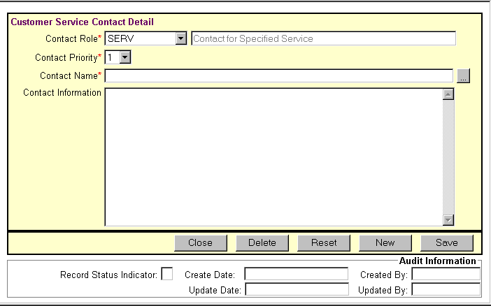

Contact Role – Prefilled with Contact for Specified Service.

Contact Priority – Select from 1 – 10 in Priority via drop-down menu.

Contact Name – Must use Look-up on Contact Search screen.

Contact Information – Will be extracted from Contact Search screen when contact selection made.

From this screen you can QUICKY GOTO – Customer, Service Location, Facility, Managed Object, PVC, Order History, Correlation, Correlation (Root).

Changing a Customer Service Type (Upgrade/Downgrade the service)

Terminate the old service and add a new customer service. See Create Customer Service process.

DO NOT change the service type on a Customer Service that is operational. This will cause problems for Billing. If for some reason the service type of a customer service must be changed, ensure Customer Care – Billing Specialists are informed. This process creates an audit trail.

Moving the location of a Customer Service
- Select the correct address, or create a new one if it does not exist.
- Select or build a service location name.
- When the service is physically moved, change the service location name on the Detailed Circuit Info screen.
- Add a comment.

CUSTOMER CONTACT – E-MAIL SET-UP
***Please read Section 2.0 ‘Standard Features of SMA’***

Go to the SMA Main Window – Customer Services then click Email Setup.

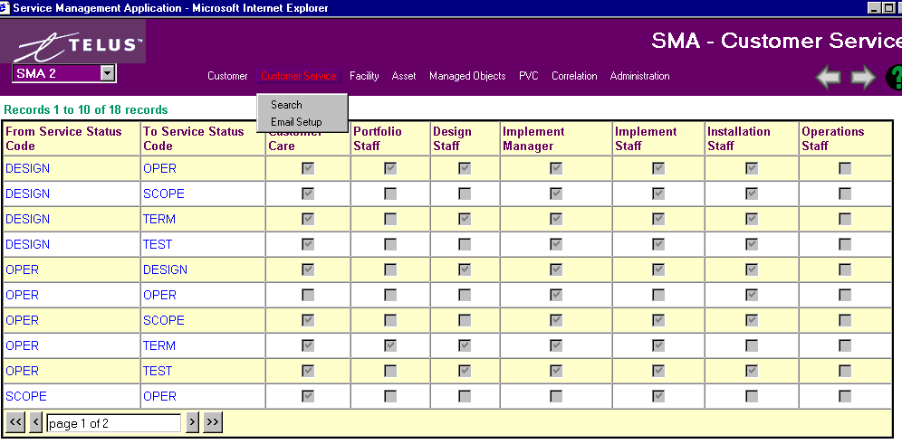

The table above shows which groups will receive automatic email distribution when a service status changes form one status to another (service status transition eg. Design to Testing). When an email message is sent the email address of the managers and specialist are retrieved from the staff table. If the email address is invalid the Microsoft Exchange resolve dialog will appear. If the user selects to cancel the resolution dialog no email message will be sent.

FACILITIES
***Please read Section 2.0 ‘Standard Features of SMA’***

FACILITY SEARCH
A facility is a circuit that is ordered from outside of TAC. The facility types are: DCS, Fibre, Frame Relay, ISDN, ADSL, T1 or XDSN.
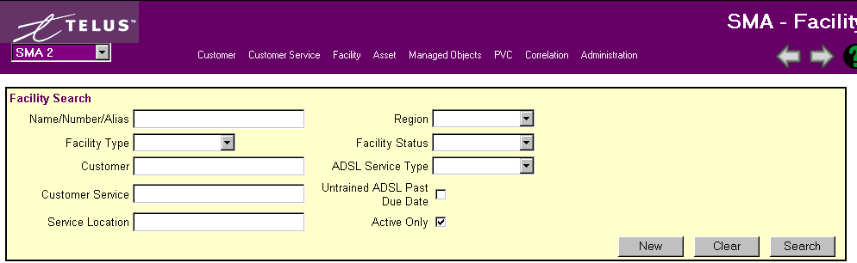
Search for the facility name using any of the fields shown above.

A Facility name, number or Alias can be used in the Facility field when searching.

A Legal name, short name, or alias name can be used in the Customer Name field when searching.

Remember the more fields you define the narrower your search results.

If you are not sure of the full name, use the ‘%’ wild card within any of your inputs. Wild cards are not necessary at the end of your search.

A list of facilities will appear from the Search query. If it is taking a long time or you hit Search without putting any criteria down just hit the ‘ESC’ button on your PC to stop the task.

SEARCH RESULTS:
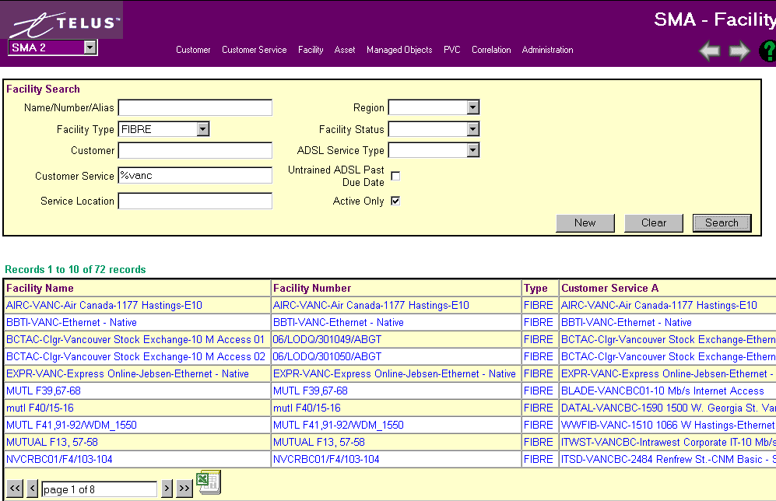
Also shown on this screen are Service Location A & B, Region and Service Status

Shows amount of records found. Use arrow bars at bottom of screen to either go page by page (single arrows) or to the first or last page (double arrows). You can also jump to a page by typing the # into the box.

FACILITY DETAIL GENERAL INFORMATION

The facility Detail screen has different criteria for each facility type, i.e. ADSL, FIBRE, FR, etc.
A circuit is a “physical” path on the network on which electronic data can travel from one point to another. While a network connection is a “logical” connection between two service locations, it is “physically” built as one or more circuits. It is crucial to accurately measure/monitor traffic on every circuit because this is the source of all customer usage calculations required for billing. Currently the following circuits types have been identified: ATM, Fibre, Frame Relay, xDSL and ISDN.

STANDARD FIELDS:
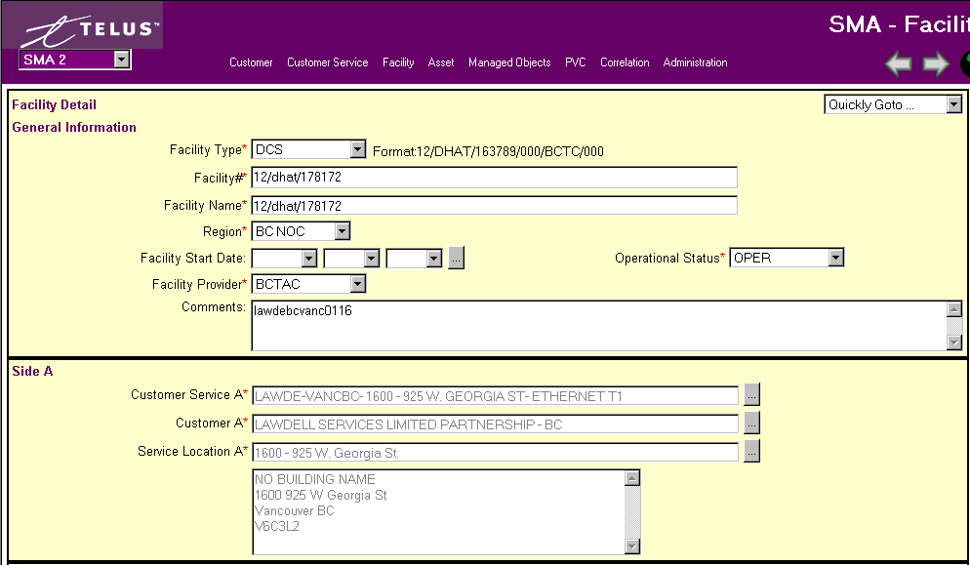
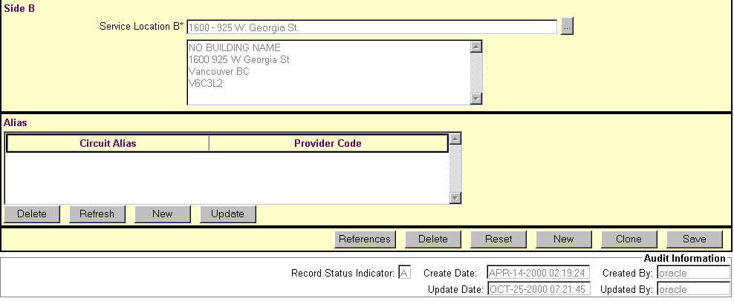

Facility Type – Select type of facility that is being ordered from drop-down box.

Facility # - Once the type of facility is selected an example of a circuit number will be shown beside the field. Examples are:
Fibre - 06/LODQ/274338/000/ABGT
Frame Relay (FR) - 55/QHDQ/102250/003/BCTC
ISDN - 403-207-8826 / 06/IDDA/305022/001/ABGT
xDSL - 06/ARDR/315992//ABGT
DCS - 12/DYDT/181481/000/BCTC/000
T1 - 06/DHAT/321123/000/BCTC

Facility Name – The Facility name will default to the Facility #, however, it can be overwritten.

Facility Start Date – The facility start date specifies the date that the circuit was operational and available for use by the customer. Either use drop-down menu or look-up button.

Facility Provider – select from drop-down menu which area the circuit belongs to.

Region – select from drop-down menu which NOC region is responsible for circuit.

Operational Status – The Status helps to define the stage that the circuit is in.
OPER - Operational. This status indicates that the facility is being used by a Customer Service, but is not being billed.
PNDOUT - Pending Out – circuit is coming out
DEFINE - This is used to indicate that the circuit is being built in SMA.
SPARE - Not used, should be deleted from list.
TERM - Terminated. This status indicates that the facility is no longer in use by a Customer Service.

Comments – Any additional comments concerning this facility.

Side A - When a new circuit is entered in to the system, Customer Service A is always required. This identifies which customer and for what service the circuit belongs.

Customer Service A – Must use look-up button to the Customer Service Search screen.

Customer A – Must use look-up menu to the Customer Name Search screen.

Service Location A – Must use look-up menu to Service Location Search screen. The Service Location A defines the “from” location. The circuit begins at the A (from) location and connects to the B (to) location. The Service Location defines every aspect of a locations whereabouts for a specific customer. It begins by stating the city that the service location can be found in. The city name should be full-length beginning with a capital letter. Following it is the name of the organization. The client short name comes in place for entering the name of the organization. This should be the same short name as seen on the main Customer Management screen. Last is the street address. A minus sign ( - ) with a space on either side should be placed between each section as a divider.

Example: Calgary - TAC - CO - Suite 200 355 - 4th Ave SW

Side B - Customer Service B is only required when a PVC circuit or network connection is entered into the system

Service Location B – Must use look-up menu to Service Location Search screen. The Service Location B defines the “to” location. The circuit begins at the A (from) location and connects to the B (to) location. The Service Location defines every aspect of a locations whereabouts for a specific customer. It begins by stating the city that the service location can be found in. The city name should be full length beginning with a capital letter. Following it is the name of the organization. The client short name comes in place for entering the name of the organization. This should be the same short name as seen on the main Customer Management screen. Last is the street address. A minus sign ( - ) with a space on either side should be placed between each section as a divider.

Example: Edmonton - EPSB - One Kingsway Ave

Clone Circuit
This button will create a new circuit which is identical to the circuit displayed, minus the Circuit Name and Circuit #. These fields have to be populated with the new circuit name and number in order to save the circuit.

Comments
The Comment field can be used for any comments or extra information. This field is free writing of up to 2000 characters.

Alias Circuit Numbers: Only complete this information when a circuit used in the Customer Service is provided by a company other than TAC. This field holds information about the circuit that can be used to refer to it in the other company.

Provider Code – The name of the company providing the circuit.

Alias Circuit Number - The name the circuit is referred to by the provider company.

FACILITY DETAILS SPECIFIC:

ADSL:

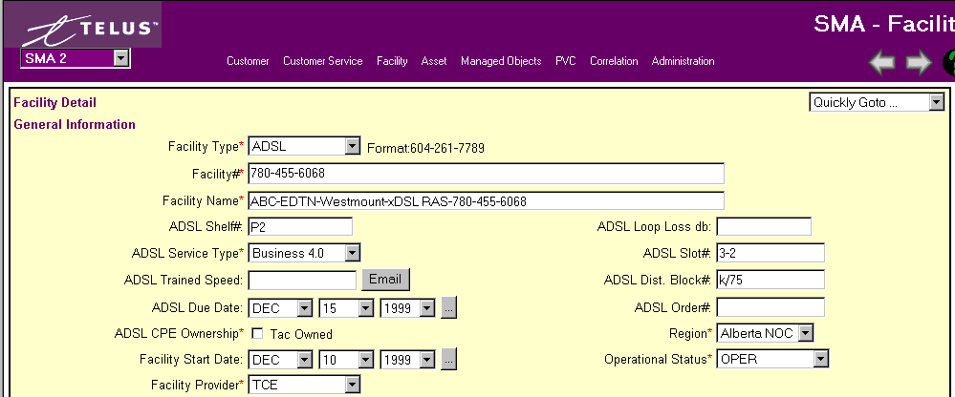

ADSL Shelf , ADSL Service Type, ADSL Trained Speed, ADSL Loop Loss db, ADSL Dist. Block# - Details of ADSL facility. See Infosource for additional informations.

ADSL Due Date: When facility ready for customer to use.

ADSL Order# - Order number installing service.

ADSL CPE Ownership – Is Customer Premise equipment owned by TAC?

FIBRE:
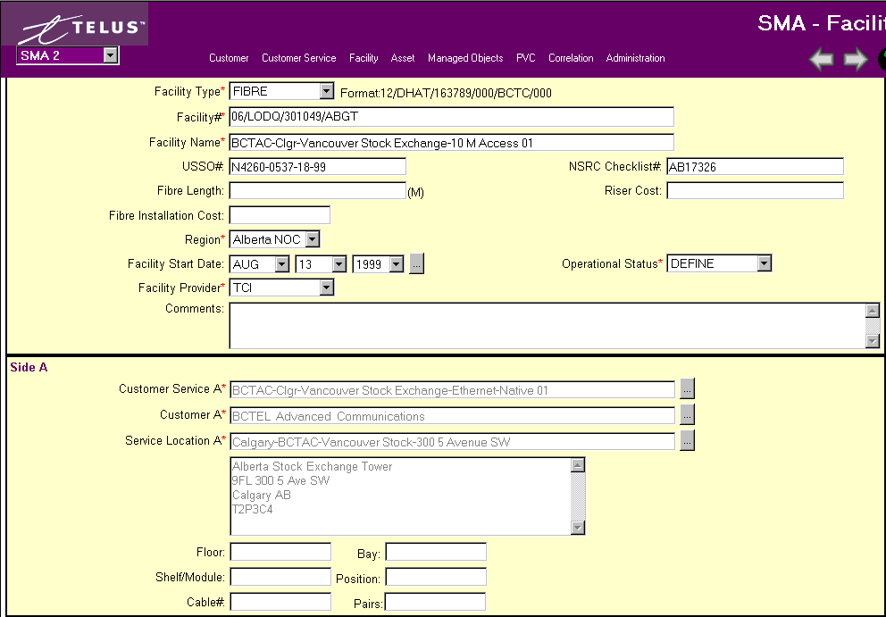

USSO# - Universal Special Service Order used to order mainstream facilities

NSRC Checklist# - National Service Response Centre checklist is used in conjunction with the USSO to order mainstream facility.

Fibre Length – length in meters

Fibre Installation and Riser Cost – Fields used to track costs of these 2 items.

On Side A & B: Indicate what Floor, Bay, Shelf/Module, Position, Cable# and Pairs used.

FR (Frame Relay):

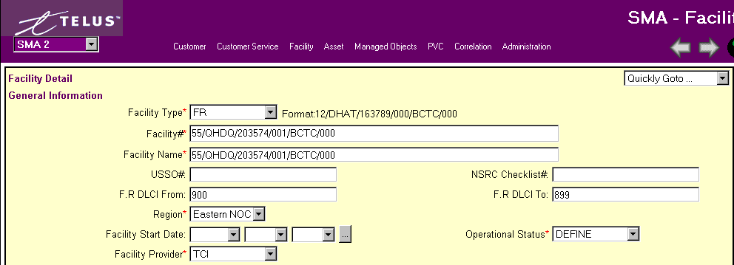

USSO# - Universal Special Service Order used to order mainstream facilities

NSRC Checklist# - National Service Response Centre checklist is used in conjunction with the USSO to order mainstream facility.

FR DLCI From/FR DLCI To – The Frame Data Link Connection Identifiers that are assigned to facility.

ISDN/T1/XDSN:

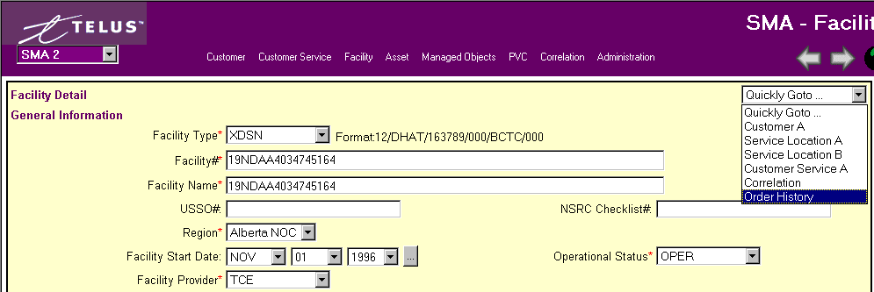
USSO# - Universal Special Service Order used to order mainstream facilities

NSRC Checklist# - National Service Response Centre checklist is used in conjunction with the USSO to order mainstream facility.

From Facility ‘QUICKLY GOTO…’, either Customer A, Service Location A or B, Customer Service A, Correlation or Order History.

ASSETS

Asset Search
***Please read Section 2.0 ‘Standard Features of SMA’***

Go to the SMA Main Window – Asset then click Search.

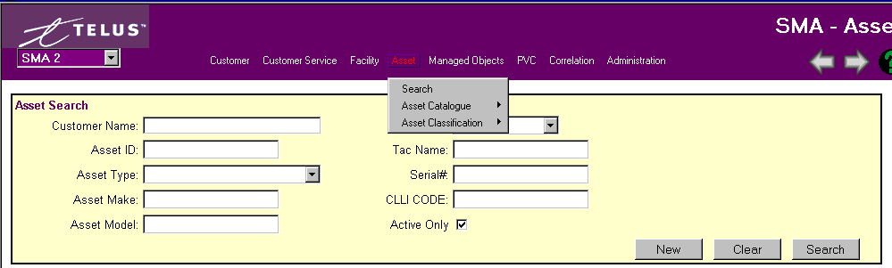

Search for an asset by using any of the fields shown above.

A Legal name, short name, or alias name can be used in the Customer Name field when searching.

Remember the more fields you define the narrower your search results.

If you are not sure of the full name, use the ‘%’ wild card within any of your inputs. Wild cards are not necessary at the end of your search.

A list of Asset Types will appear from the Search query. If it is taking a long time or you hit Search without putting any criteria down just hit the ‘ESC’ button on your PC to stop the task.

Search Results:
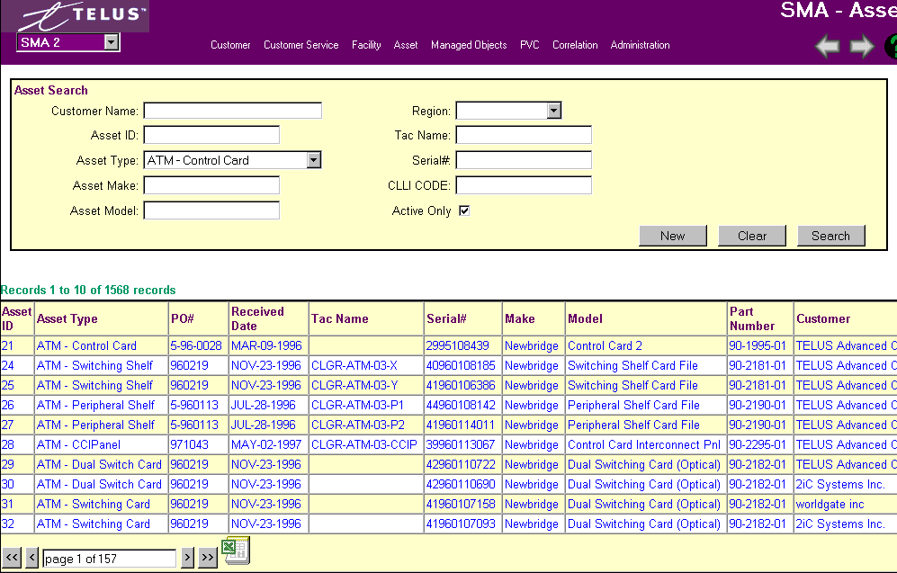

Also shown on this screen are Address and Region. Shows amount of records found. Use arrow bars at bottom of screen to either go page by page (single arrows) or to the first or last page (double arrows). You can also jump to a page by typing the # into the box.

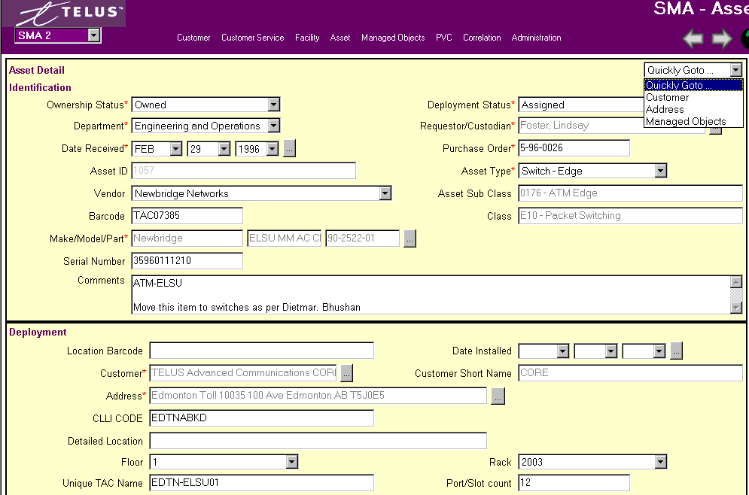
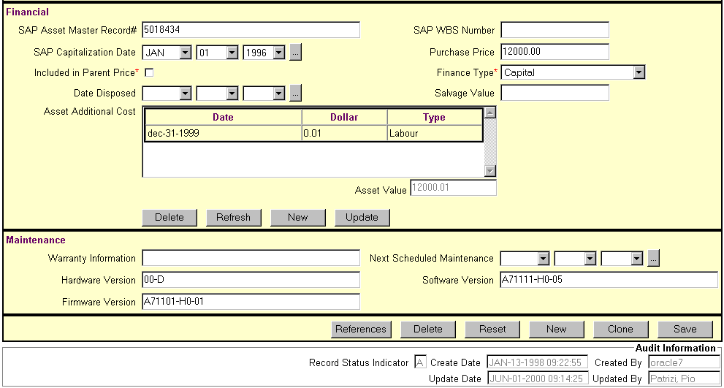

Fields:

Ownership Status - The majority of assets are "Owned”, or else they belong to a customer and TAC is simply managing them ("Not TAC").

Deployment Status - Initially set to "Pending" by the Receiver, the Installer will reset this status once the asset has been put into service. All assets that are part of the managed network should be set to "Manageable by OSC". Other assets would be "Assigned" unless they are a “Maintenance Spare". Any of the other statuses will indicate that the asset is no longer an active asset within the company.

Department – Select from drop-down box, i.e. Engineering and Operations - All items ("real" and "virtual") that are part of the configuration of a service for a customer – their make and model and their physical location. Provides an inventory of items in service with their locations, for network and configuration planning. All items ("real" and "virtual") that can be alarmed for automated trouble ticketing – their location and customer that the asset is being used for. These assets do not need to be owned by TAC as we manage equipment on behalf of customers. By linking network alarm sources to assets information regarding affected services and customers can be gleaned and the appropriate people contacted regarding current or potential problems. Managed Services - All items that we own, manage or purchase on behalf of Outsourcing clients. Provides detailed information regarding activities undertaken on behalf of outsourcing clients.

Requestor/Custodian – Must use look-up Contact Search for selection.

Purchase Order - Purchase order field required.

Asset Type - When selecting this item, check the asset sub-class information that is displayed to ensure that the asset type does map to the sub-class you would expect. Asset ID, Asset sub-class, and Class – Fields will be automatically filled when Asset Type selection made.

Make/Model/Part – Must use look-up to Asset Catalogue Search.

Serial # - Enter number from equipment.

Comments – Any additional information concerning this asset.

Vendor – Select from drop-down box company that equipment is purchased from.

Bar Code - record the bar code that could be placed on the asset

Asset Serial Number - Serial number is a required field and should only be set to "Unknown" in situations where it is genuinely difficult to determine the serial number (e.g. part is already installed deep within some other asset).

Unique TAC Names - are formatted using standards developed by Engineering and Operations. This name must match the one used in the network monitoring software to tie alerts together.

SAP Asset Management Record# and associated SAP Capitalization Date - are the indication to the system that this asset should be reconcilable to SAP Asset Management module and therefore should be included in all Reconciliation reporting.

A number of the fields on this screen are mandatory for assets that are “grouped” in SAP. Many of the fields are currently disabled for assets that are held individually in SAP (no need to hold the data in two places). For SAP “pooled” assets, entry is optional.

The additional asset dollar entry fields are used to capture information about costs that are attributable to the asset but are over and above the direct purchase price.

Maintenance section - provides free format fields to hold maintenance scheduling and version number information.

Cloning - From the asset add/edit screen, the currently displayed asset can be used as a template to create a “clone” asset. The new asset simply uses the field values from the old asset, to facilitate data entry. There is no permanent relationship between the two records. When entering a new asset, finding a similar one and cloning it, will be significantly faster than entering all the data from scratch.

Asset Catalogue Search - Make, Model and Part Search:

***Please read Section 2.0 ‘Standard Features of SMA’***

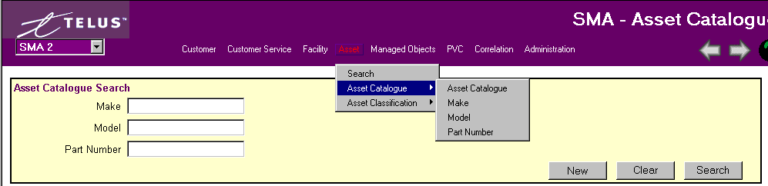

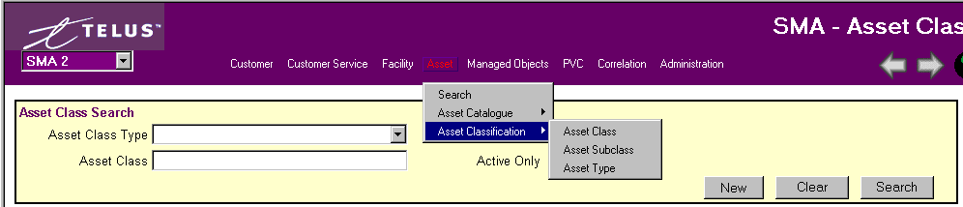

Searches for a make, model, part number or Asset Class, Subclass, Type can be done through Asset Catalogue search or individually through Make, Model or Part Number Search.

Remember the more fields you define the narrower your search results.

If you are not sure of the full name, use the ‘%’ wild card within any of your inputs. Wild cards are not necessary at the end of your search.

A list of customers will appear from the Search query. If it is taking a long time or you hit Search without putting any criteria down just hit the ‘ESC’ button on your PC to stop the task.

Creating/Deleting Asset Catalogue, Make, Model, Part Number and Asset Class, Subclass or Type
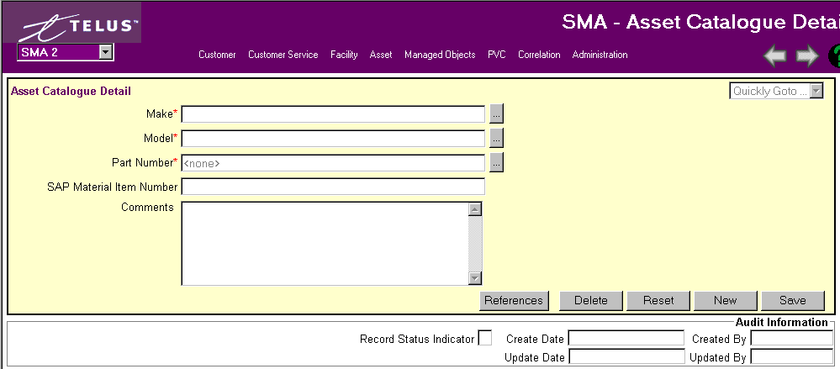

Add/Delete Make, Model or Part Number from Asset Catalogue Details. Each item will require you use the Look-up buttons for each Search screen.

Asset Class, Subclass and Type are usually input by the Finance area.

Managed Objects – Design Engineers
***Please read Section 2.0 ‘Standard Features of SMA’***

Managed Objects are classified as anything that is managed or monitored by TAC. They are defined for network and service management purposes and are the fundamental components that make up a customer service. The managed objects provide the necessary correlation between services and network resources.

Search Managed Objects

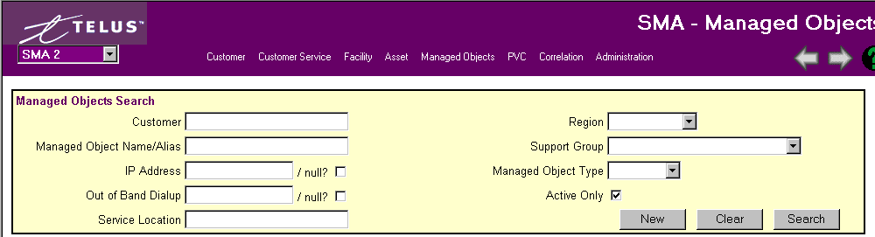

Search for a Managed Object by using any of the fields shown above.

A Legal name, short name, or alias name can be used in the Customer Name field when searching.

Remember the more fields you define the narrower your search results.

If you are not sure of the full name, use the ‘%’ wild card within any of your inputs. Wild cards are not necessary at the end of your search.

A list of Object Names will appear from the Search query. If it is taking a long time or you hit Search without putting any criteria down just hit the ‘ESC’ button on your PC to stop the task.

Create a Managed Object

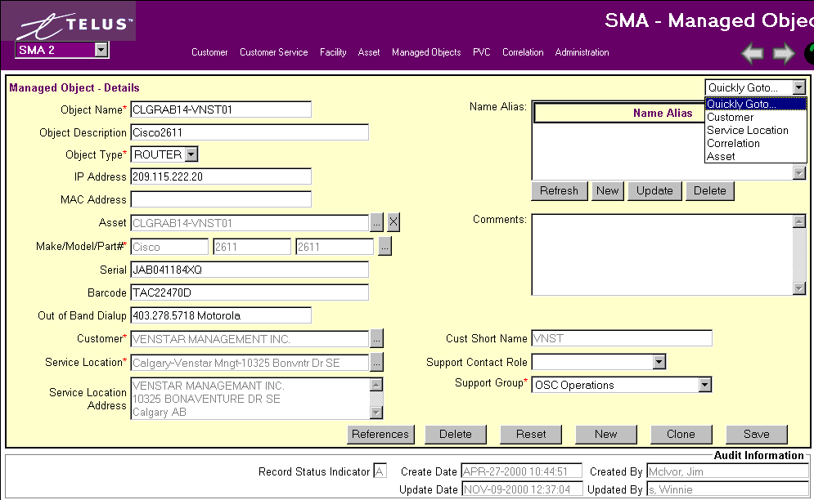

Fields:

Object Name – The Managed Object Name is usually described as a device name or a URL. A list of all managed object name begins with the CLLI code of the Central Office the device is located in or works out of, followed by the customer short name, followed by a number to reveal how many devices there are for that customer. The URL’s must be copied exactly from their website.

Examples: EDTNAB02-BLCR01
VANCBC01-CADV01
www.tac.telus.com

Object Description – A freeform field that is used to describe or differentiate the Managed Object when needed. This field should be used to specify the device type i.e. Cybersurf AS5300

Object Type – Select from the dropdown selection list. The Managed Object Type controls the fielding in order to collect additional information i.e. for routers & edge devices.

Alias Name – If the Managed Object is referenced by another name outside of TAC, enter it here.

IP Address – The address OSC uses when sending SNMP requests and pings.

MAC Address – The hardware address of the interface to which the Managed IP Address is assigned. It enables the Operations Service Centre to identify TAC’s router for management purposes. This prevents unauthorized access from the customers network into TAC’s Operations Service Centre. Only OSC bound traffic is allowed to pass through the secure connection. The MAC Address consists of 12 characters, both letters and numbers. They are grouped into two’s with divisions by a minus sign ( - ).

Example: 00-00-0C-FE-F8-30

Asset, Make/Model/Part#, Serial#, Bar Code - Look-up button and information from Asset screen.

Out of Band Dial up - This is the phone number used by OSC to make contact with the managed object when the primary circuits are unavailable. These are considered a ‘Facility’ and are added to the database and attached to the Customer Service by the Implementation Managers. Only the phone numbers (IBL Facilities) that are attached to the Service Location will appear in this list. Select the number which applies to the Managed Object. If the correct number does not appear in the list, contact the Implementation Manager who is specified on the Customer Service Management window.

Customer/Customer Short Name - All managed objects must be linked to a customer service. Must use Look-up menu on Customer Search screen.

Service Location/Service Location Address – Look-up menu from Service Location Search screen. This list contains the addresses of all customer services in the database. If the Customer Service Location does not exist in the list, contact the Customer Service Management Super User (Lee Ettinger).

Support Contact Role - This is a finer breakdown of the Support Group.

Support Group - The group responsible for Service Assurance.

Comments – This is a freeform field where the design engineer can enter any additional information about the managed object that is not captured elsewhere.

Inactivating Managed Objects

A managed object can be inactivated by selected ‘TERM’ from the Status field dropdown list. The system will automatically set the Termination Date to the current date. If equipment is no longer at Customer Service location it can be deleted from the Managed Object. This equipment will still show up in the Asset Detail Screen.

Move from Managed Objects to Quicky GoTo… which will take you directly to Customer, Service Location, Correlation and Asset screens.

ATM PVC Management
***Please read Section 2.0 ‘Standard Features of SMA’***

Operations Service Centre (OSC) has accepted the responsibility to ensure that the logical customer service connections are maintained so that usage can be billed to customers.

When a new ATM PVC is set up in the ATM Network it will automatically be detected and inserted into the database with a Operational Status of ‘UNKNWN’.

IMPORTANT
In order to bill for usage on ATM PVCs, the following PVC Management information must be completed:
Usage Calc Type (Billing),
Side A Information,
Side B Information.

FOR EACH DAY THAT THE ABOVE PVC MANAGEMENT DATA IS MISSING, THE CUSTOMER WILL NOT BE BILLED FOR THE USAGE COLLECTED ON THAT DAY.

Search PVC
******BE SURE TO CHECK THE 'OUTSTANDING PVC' BOX TO OBTAIN THESE STATS******

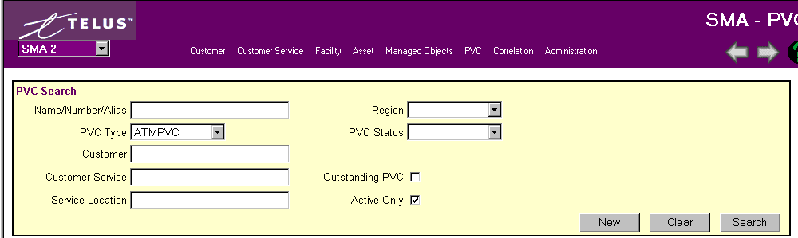

Search for a PVC by using any of the fields shown above.

A Legal name, short name, or alias name can be used in the Customer Name field when searching.

Remember the more fields you define the narrower your search results.

If you are not sure of the full name, use the ‘%’ wild card within any of your inputs. Wild cards are not necessary at the end of your search.

A list of PVCs will appear from the Search query. If it is taking a long time or you hit Search without putting any criteria down just hit the ‘ESC’ button on your PC to stop the task.

Search Results:
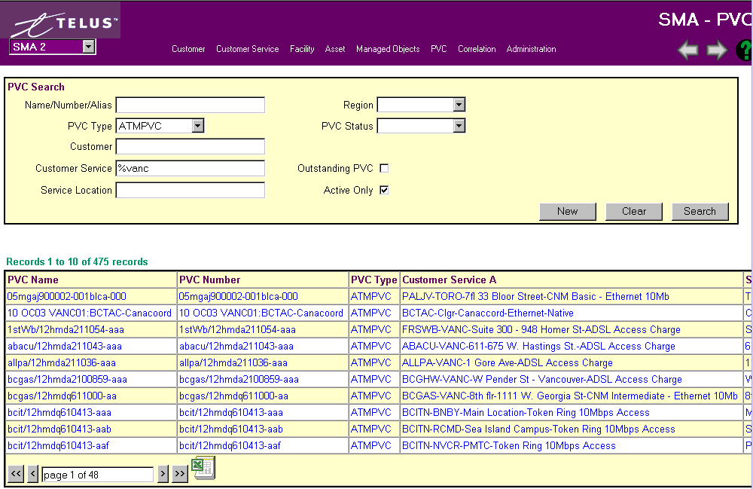

Also shown on this screen are Customer Service B, Service Location A & B, Region and PVC Status. Shows amount of records found. Use arrow bars at bottom of screen to either go page by page (single arrows) or to the first or last page (double arrows). You can also jump to a page by typing the # into the box.

Changing a record:

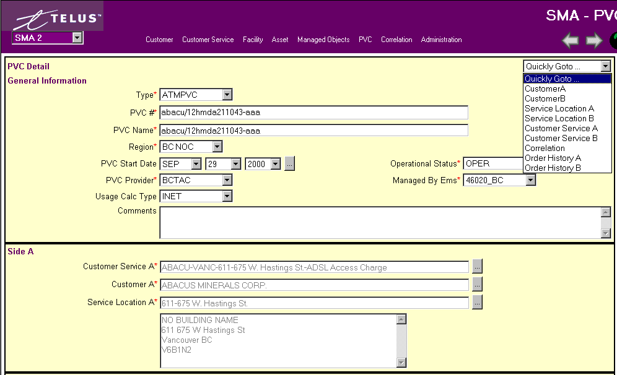
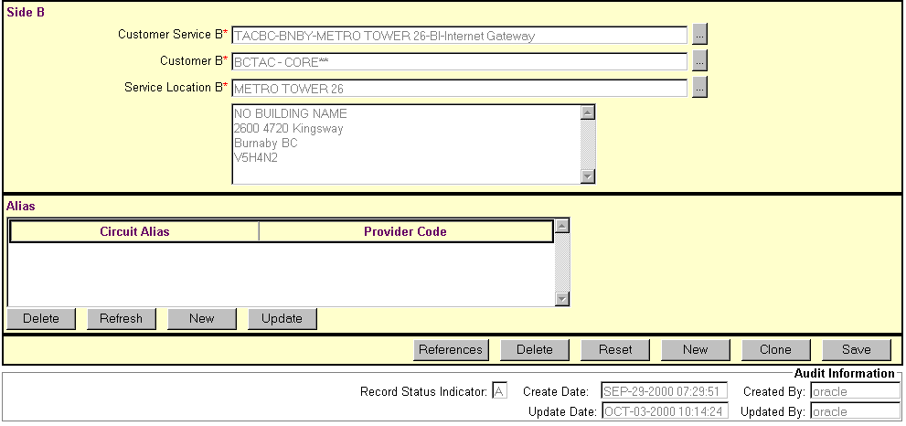

PVC Detail Fields:

Type – Always ATM-PVC.

PVC #/PVC Name - The PVC # is a unique number that references the PVC circuit. This field is populated with the circuit number from the ATM Network when the circuit is auto discovered. The PVC Name will default to be the same as the PVC#, however it may be overwritten should you wish to have a more user-friendly description.

PVC Start Date – This is the date that the ATM PVC was auto discovered. It is the date that the system can start collecting usage. The date will be inserted by the circuit discovery process, however it can be overwritten.

PVC Provider – This is the organization that provisions the circuit. For ATM PVCs the circuit provider will always be TAC. The system will default the value to TAC, however the value can be overwritten.

Operational Status Code – Drop-down menu used for selection, i.e. UNKNWN – Unknown. This status is used for ATM PVC circuits only. A status of UNKNWN is set when the ATM PVC is auto discovered by the Usage Collection Process. A circuit that is in ‘UNKNWN’ status will not generate revenue because the usage will not be passed to the billing system. OPER – Operational. This status indicates that the PVC has been fully connected. It is collecting usage for a Customer Service. TERM – Terminated. This status indicates that the PVC is no longer in use by a Customer Service. PNDOUT - Pending out of circuit. SPARE - PVC not in use at this time. DEFINE - being built in SMA

Managed By EMS – This is the name of the Element Management Software that monitors the circuit.

Usage Calc Type: There are 3 options available, these are:

FREE – Choose this value when the PVC is not to be billed to the customer. For example, if you have a PVC which is to be used for stats collection only, set this indicator to ‘Free’.

INET – Choose this value when the PVC connects an internetworking service where both sides of the service are being billed for receipt usage.

LANIC – Choose this value when the service is a LAN Interconnect and only one side of the service is being billed to a customer and the other side connects to a TAC CO or POP.

Side A and Side B information is the logical connection of the PVC circuit. Side A and Side B are MANDATORY fields. They are required for the billing system and customer reporting to function properly.

Side A
Customer Service A - must be selected from the Look-up button that goes to Customer search screen.

Customer A - will default to Customer name specified on the Customer Service Management window.

Service Location A – will default to the service location specified on the Customer Service Management window.

Side B
Customer Service B - must be selected from the Look-up button that goes to Customer search screen.

Customer A - will default to Customer name specified on the Customer Service Management window.

Service Location B - will default to the service location specified on the Customer Service Management window.

Comments – A freeform field where information not captured elsewhere can be entered.

Circuit Alias - Any other Facility/PVC alias which would help you to search for this PVC can be entered here.

Provider Code – The name of the company providing the circuit. Used with Circuit Alias information.

CORRELATION MANAGEMENT - Making a Customer Service Operational - OSC
***Please read Section 2.0 ‘Standard Features of SMA’***

Search Correlated Elements
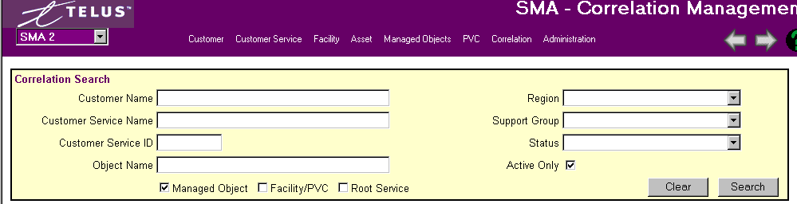
Search for a Correlation information by using any of the fields shown above.

A Legal name, short name, or alias name can be used in the Customer Name field when searching.
Remember the more fields you define the narrower your search results.
If you are not sure of the full name, use the ‘%’ wild card within any of your inputs. Wild cards are not necessary at the end of your search.

A list of customer service names will appear from the Search query. If it is taking a long time or you hit Search without putting any criteria down just hit the ‘ESC’ button on your PC to stop the task.

If the Customer Service Name does not appear in the list, contact the Implementation Manager.

Search Results:
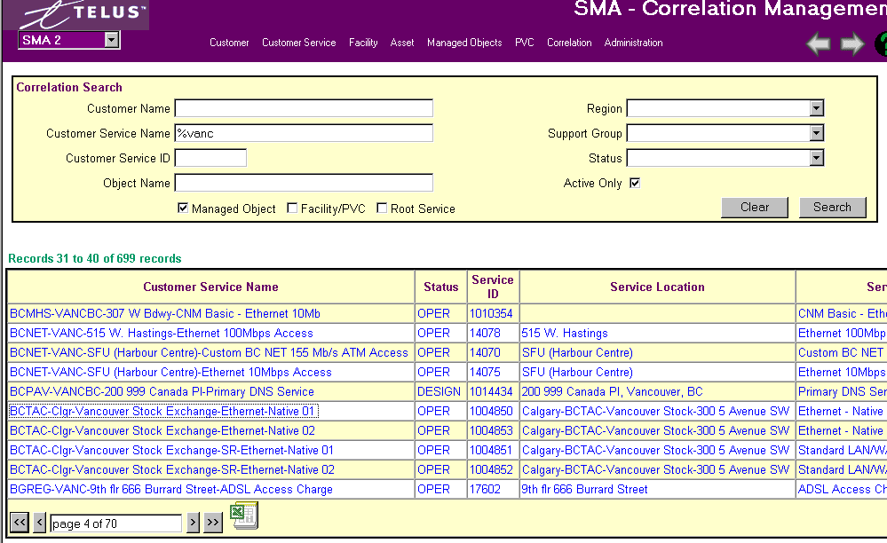

Also shown on this screen are Service Type, Customer Name, and Region. Shows amount of records found. Use arrow bars at bottom of screen to either go page by page (single arrows) or to the first or last page (double arrows). You can also jump to a page by typing the # into the box.

Attaching Correlated Elements to the Customer Service (Correlation Management)

To attach a network element to a customer service you want to select a managed object, PVC, facility or Root service to the Correlated Elements on the Managed Correlation Detail screen.

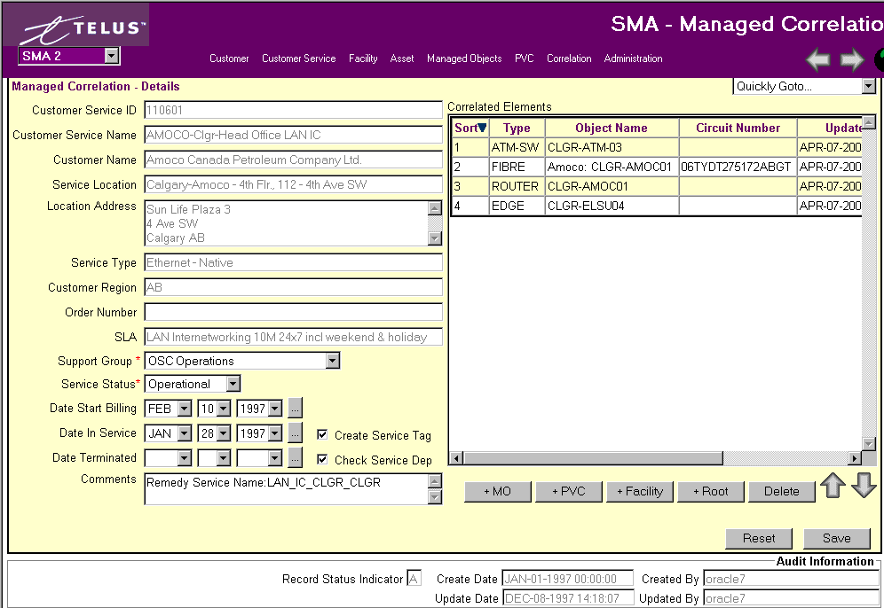

The Correlated Elements are sub-divided into 4 sub-component types, Managed Objects, PVCs, Facilities and Root Services. A root service is a service that correlates commonly used network elements that are used by a variety of other services, i.e. infastructure. When choosing one of these elements the search screen will appear.

The list of Correlated Elements can be sorted by any of the fields by choosing the field title. Each element can be moved on the list using the down and up arrows found beside the Delete button.

To REMOVE a Correlation Element from a Customer Service, select the component from the list by clicking on it. Then click on the ‘Delete’ button.

To VIEW a Correlation Element, select the Element Name from the list and use the Quickly GoTo.. menu.

Activating/Terminating the Customer Service

There are 3 valid Status Codes for a customer service.
DESIGN – Implementation Managers are responsible for adding new customer services. New customer services have a status of design. A design status indicates that the customer service is not being monitored or supported by the Operations Service Centre (OSC) nor is the customer being invoiced for the service.
OPERATIONAL – The Operations Service Centre (OSC) is responsible for changing the status of a customer service to operational. An operational status indicates that the customer is free to use the service, OSC is fully monitoring and supporting the customer service and Customer Care is invoicing the customer for the service.
TERMINATED – The Operations Service Centre (OSC) is responsible for changing the status of a customer service to terminated. A terminated status indicates that the customer can no longer access and use the service, OSC is no longer monitoring and supporting the customer service and Customer Care is no longer billing the customer for that service.

To ACTIVATE a customer Service, set the Customer Service Status to ‘Operational’. The system will automatically set the Date In-Service to the current date. This date can be overwritten.
To DEACTIVATE a customer service, first remove all network elements that are correlated to the service (see Attaching Correlation Elements to the Customer Service (Correlation Management process). Next set the Customer Service Status to ‘Terminated’. The system will automatically set the Date Terminated to the current date. This date can be overwritten.

IMPORTANT:
When a customer service is activated or deactivated, the Customer Service Manager and the Billing Specialist must be informed. The system will generate an E-mail note. Verify the recipients of the note and confirm that there is a Customer Service Manager and a Billing Specialist, if not add them to the recipient list. PRESS THE SEND BUTTON ON THE E-MAIL…DO NOT CANCEL THE E-MAIL MESSAGE.

Use QUICKLY GoTo… to go directly Customer Service, Customer, Order History, Root Customer Service, Facility, Managed Object or PVC.

Administration
***Please read Section 2.0 ‘Standard Features of SMA’***

The Admin searches are mainly informational screens, that are maintained by various groups, i.e. Marketing, Super-Users. The Security Matrix will show what access each group has to SMA.
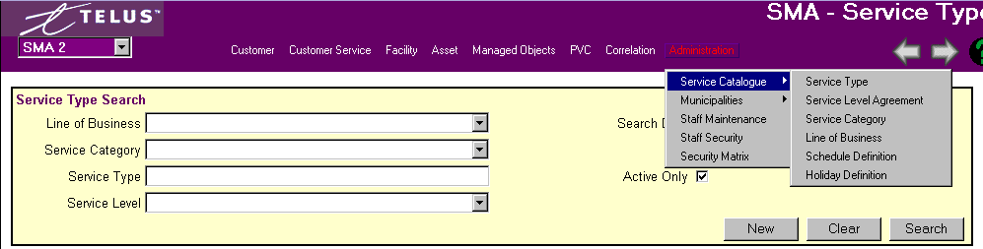
Remember the more fields you define the narrower your search results.
If you are not sure of the full name, use the ‘%’ wild card within any of your inputs. Wild cards are not necessary at the end of your search.

The CLLI code is a four character city code, followed by a two character province code, followed by a two character office code. i.e. CLGRAB02

